**Functional Design Document**

**Reporting**

Event Setup & Creation

Prepared for :

[Company] Testing Team

Project :

Event Management

|  |  |
| --- | --- |
| Author : | Purnesh Dixit, Associate Technical Consultant. |
| Date : | 20th Oct, 2014 |
| Version : | (Draft) |

# **Document Version Control**

|  |  |  |  |
| --- | --- | --- | --- |
| Date | Author | Version | Change Reference |
| 20/10/2014 | Purnesh Dixit |  | Initial Draft |
|  |  |  |  |
|  |  |  |  |
|  |  |  |  |
|  |  |  |  |
|  |  |  |  |
|  |  |  |  |

# **Document Approvals**

|  |  |  |  |
| --- | --- | --- | --- |
| Name | Version Approved | Position | Date |
|  |  |  |  |
|  |  |  |  |
|  |  |  |  |
|  |  |  |  |

# **Document Properties**

|  |  |
| --- | --- |
| Item | Details |
| Form Title | Event details |
| TFS Reference |  |
| Author | Purnesh Dixit |
| Functional Area | Event creation and setup |
| [Company] Owner |  |
| [Company] Project Manager |  |
| Microsoft Owner |  |
| Microsoft Project Manager |  |

Contents

**Document Version Control** 2

**Document Approvals** 2

**Document Properties** 2

**1** **Introduction** 5

**2** **Terms** 5

**3** **Assumptions** 5

**4** **Dependencies** 5

**5** **Scenarios** 6

**6** **Business Requirements** 6

**7** **Functional Requirements** 6

**8** **Logical Data Model** 7

**9** **Form overview and steps to follow** 8

**1.** **Form name: Event type group table** 8

**a.** **Description:** Master form for managing the groups based on event categories for the events organized, like Family\Corporate. 8

**b.** **Steps** 8

**Schema Info: FthEventTypeGroup** 9

**2.** **Form name: Event type master table** 10

**a.** **Description:** Master form for managing the types of events organized. 10

**b.** **Steps** 10

**Schema Info: FthEventTypeMaster** 12

**3.** **Form name: Food preferences** 13

**a.** **Description:** Master form for managing the food preferences of events organized. 13

**b.** **Steps** 13

**Schema Info: FthFoodPreference** 14

**4.** **Form name: Pickup drop location** 15

**a.** **Description:** Master form for managing the pickup drop locations of events organized. 15

**b.** **Steps** 15

**Schema Info: FthPickupdropLocation** 16

**5.** **Form name: Allergies master** 17

**a.** **Description:** Master form for managing the allergies(if any) of events organized such that that can be matched with the default allergies of employees for alerting them with the same at the time of accepting invitation. 17

**b.** **Steps** 17

**Schema Info: FthAllergies** 19

**6.** **Form name: Event** 20

**7.** **Form name: Event** 21

**Schema Info: FthEventDetails** 23

**8.** **Form name: Pickup drop location** 25

10 Security Definitions and Role Mapping 28

10.1 Privilege Definition 28

10.2 Privilege to Duty Mapping 28

10.3 Duty Definition 28

10.4 Duty to Role Mapping 28

11 Unit Testing 30

11.1 Data Requirements 30

11.2 Unit Test Plan 30

12 Acceptance 31

Table of Figures

*Table 1 : Terms* 5

*Table 2 : Assumptions* 5

*Table 3 : Dependencies* 5

*Table 4 : Business Requirements* 6

*Table 5 : Functional Requirements* 6

*Table 7 : Privilege Definition* 28

*Table 8 : Privilege to Duty Mapping* 28

*Table 9 : Duty Definition* 28

*Table 10 : Duty to Role Mapping* 28

# **Introduction**

To setup the event preferences and types and create an event with family and corporate category

# **Terms**

|  |  |  |
| --- | --- | --- |
| No. | Term | Definition |
| 1. |  |  |
| 2. |  |  |
| 3. |  |  |
| 4. |  |  |

*Table 1 : Terms*

# **Assumptions**

|  |  |
| --- | --- |
| No. | Assumption |
| 1. |  |
| 2. |  |
| 3. |  |

*Table 2 : Assumptions*

# **Dependencies**

|  |  |  |  |  |
| --- | --- | --- | --- | --- |
| No. | Team/Contact | Type[1] | Description | Link |
| 1. |  |  |  |  |
| 2. |  |  |  |  |
| 3. |  |  |  |  |

*Table 3 : Dependencies*

# **Scenarios**

|  |  |
| --- | --- |
| Scenario Name | Setup event preferences and types and create event with family and corporate category |
| Persona(s) |  |
| Problem Statement | No functionality for managing company’s events in standard AX |
| Background |  |
| User Goal | To be able to setup and create the events |

# **Business Requirements**

|  |  |  |
| --- | --- | --- |
| No. | Business requirement | Priority[2] |
| 1. | Event creation and setup | 1 |
| 2. |  |  |

*Table 4 : Business Requirements*

# **Functional Requirements**

|  |  |  |
| --- | --- | --- |
| No. | Functional requirement | Business requirement(s) |
| 1. | Setup the event preferences and types and create events | 1 |
| 2. |  |  |
| 3. |  |  |
| 4. |  |  |

*Table 5 : Functional Requirements*

# **Logical Data Model**

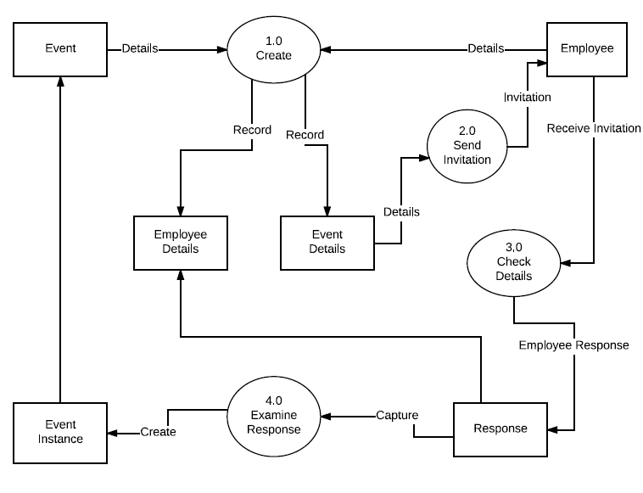

# **Form overview and steps to follow**

Click Area Page node: Event Management -> Setup -> Event type group.

1. **Form name: Event type group table**
   1. **Description:** Master form for managing the groups based on event categories for the events organized, like Family\Corporate.
   2. **Steps**

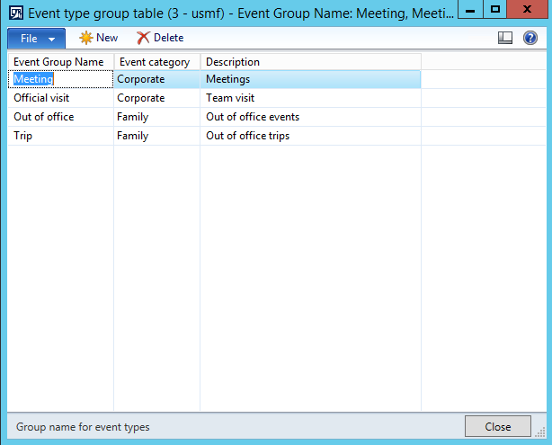

2. Click the New button.

3. Create a new record in the Event type group table form.

3. Change Event Group Name from '' to 'Out of office'.

4. Change Event category from 'Corporate' to 'Family'.

5. Change Description from '' to 'Out of office events'.

6. Create another record in the Event type group table form.

7. Change Event Group Name from '' to 'Meeting'.

8. Change Event category to 'Corporate'.

9. Change Description to 'Meetings events'

10. Click the Close toolbar button.

11. Close the Event type group table form.

### **Schema Info: FthEventTypeGroup**

Change Type: New

#### Properties

|  |  |
| --- | --- |
| **Description and Justification:** |  |
| **Property** | **Value** |
| Configuration Key | FthEventManagement |
| Label | Event type group table |
| Primary Index[3] | SurrogateKey |
| Clustered Index | SurrogateKey |
| Table Group | Miscellaneous |
| Title Field 1 | EventTypeGroupName |
| Title Field 2 | Description |
| OCC Enabled | Yes |
| Cache Lookup | None |
| Save data per company | Yes |
| AOSAuthorization | None |
| Replacement Key |  |
| Developer Documentation | This table consists of event type groups. |

#### Fields

*State all your fields and their properties; ensure identifications of H/M/LBI fields and which fields should be trimmed on the server*

|  |  |  |  |  |  |
| --- | --- | --- | --- | --- | --- |
| **Field Name** | **Data Type** | **Mandatory (Y/N)** | **Change Type** | **Configuration Key (highlight keys which can be disabled when the table configuration key is enabled)** | **Other Properties**  **(Should this field be trimmed on the server (AOSAuthorization)?)** |
| Description | String | No | Add |  | EDT: Description |
| EventCategory | Enum | No | Add |  | EnumType: FthEventCategory |
| EventTypeGroupName | String | Yes | Add |  | EDT: FthEventTypeGroupname |

13. Click Area Page node: Event Management -> Setup -> Event Types.

1. **Form name: Event type master table**
   1. **Description:** Master form for managing the types of events organized.
   2. **Steps**

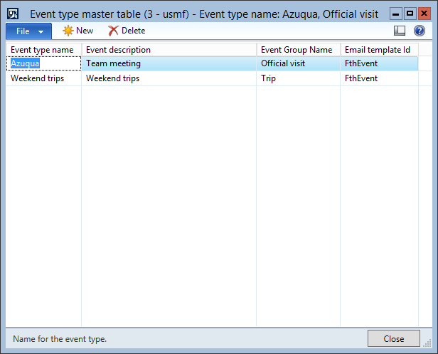

14. Click the New button.

15. Create a new record in the Event type master table form.

15. Change Event type name from '' to 'Overnite trips'.

16. Change Event description from '' to 'Overnite trips'.

17. Change Event Group Name from '' to 'Out of office'.

18. Change Email template Id from '' to 'FthEvent'.

20. Click the New button.

21. Create a new record in the Event type master table form.

21. Change Event type name from '' to 'Team meeting'.

22. Change Event description from '' to 'Team meeting'.

23. Change Event Group Name from '' to 'Meeting'.

25. Click the Close toolbar button.

25. Change Email template Id from '' to 'FthEvent'.

27. Close the Event type master table form.

### **Schema Info: FthEventTypeMaster**

Change Type: New

#### Properties

|  |  |
| --- | --- |
| **Description and Justification:** |  |
| **Property** | **Value** |
| Configuration Key | FthEventManagement |
| Label | Event type master table |
| Primary Index[4] | SurrogateKey |
| Clustered Index | SurrogateKey |
| Table Group | Miscellaneous |
| Title Field 1 | EventTypeName |
| Title Field 2 | EventTypeGroup |
| OCC Enabled | Yes |
| Cache Lookup | None |
| Save data per company | Yes |
| AOSAuthorization | None |
| Replacement Key |  |
| Developer Documentation | This table consists of all the employees selected for every event. |

#### Fields

*State all your fields and their properties; ensure identifications of H/M/LBI fields and which fields should be trimmed on the server*

|  |  |  |  |  |  |
| --- | --- | --- | --- | --- | --- |
| **Field Name** | **Data Type** | **Mandatory (Y/N)** | **Change Type** | **Configuration Key (highlight keys which can be disabled when the table configuration key is enabled)** | **Other Properties**  **(Should this field be trimmed on the server (AOSAuthorization)?)** |
| Description | String | No | Add |  | EDT: Description |
| EventTypeGroup | String | No | Add |  | EDT: FthEventTypeGroupName |
| EventTypeName | String | Yes | Add |  | EDT: FthEventTypeName |
| TemplateId | String | No | Add |  | EDT: sysEmailId |

28. Click Area Page node: Event Management -> Setup -> Food preference.

1. **Form name: Food preferences**
   1. **Description:** Master form for managing the food preferences of events organized.
   2. **Steps**

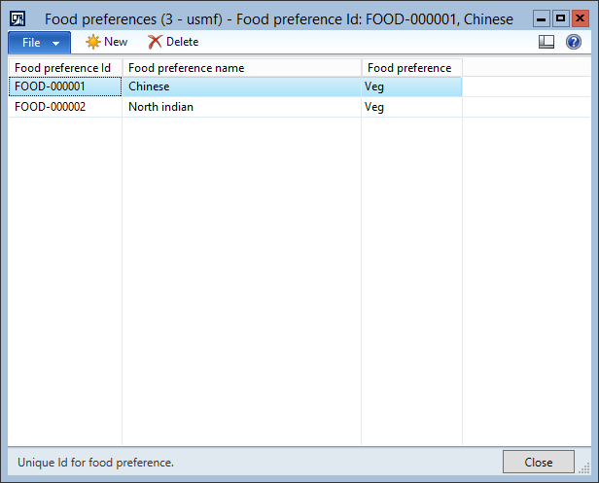

29. Click the New button.

30. Create a new record in the Food preferences form.

31. Click the Close toolbar button.

31. Change Food preference name from '' to 'Italian'.

33. Close the Food preferences form.

### **Schema Info: FthFoodPreference**

Change Type: New

#### Properties

|  |  |
| --- | --- |
| **Description and Justification:** |  |
| **Property** | **Value** |
| Configuration Key | FthEventManagement |
| Label | Food preferences |
| Primary Index[5] | SurrogateKey |
| Clustered Index | SurrogateKey |
| Table Group | Miscellaneous |
| Title Field 1 | FoodPreferenceId |
| Title Field 2 | FoodPreferenceName |
| OCC Enabled | Yes |
| Cache Lookup | None |
| Save data per company | Yes |
| AOSAuthorization | None |
| Replacement Key |  |
| Developer Documentation | This is the food preference master table. |

#### Fields

*State all your fields and their properties; ensure identifications of H/M/LBI fields and which fields should be trimmed on the server*

|  |  |  |  |  |  |
| --- | --- | --- | --- | --- | --- |
| **Field Name** | **Data Type** | **Mandatory (Y/N)** | **Change Type** | **Configuration Key (highlight keys which can be disabled when the table configuration key is enabled)** | **Other Properties**  **(Should this field be trimmed on the server (AOSAuthorization)?)** |
| DropLocation | Enum | No | Add |  | EDT: NoYesId |
| PickupDropLocationId | String | Yes | Add |  | EDT: FthPickupDropLocationId |
| PickupLocation | Enum | No | Add |  | EDT: NoYesId |
| LogisticsLocationId | Int64 | No | Add |  | EDT: RefRecId |

34. Click Area Page node: Event Management -> Setup -> Pickupdrop location.

1. **Form name: Pickup drop location**
   1. **Description:** Master form for managing the pickup drop locations of events organized.
   2. **Steps**

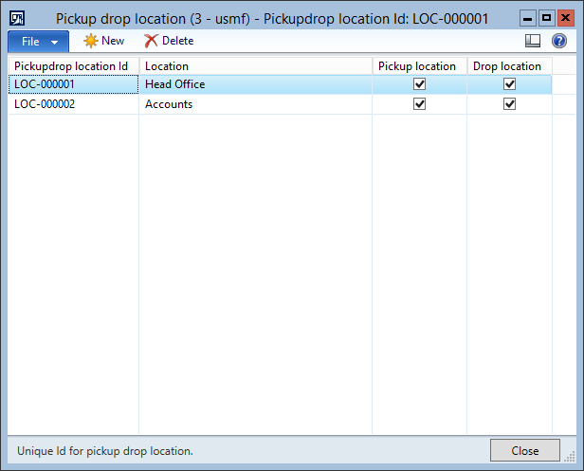

35. Create a new record in the Pickup drop location form.

35. Change Pickupdrop location Id from '' to 'LOC-000003'.

36. Change Pickup location from 'No' to 'Yes'.

37. Change Pickup location from 'Yes' to 'No'.

38. Change Pickup location from 'No' to 'Yes'.

Change Name or description from '' to 'Office'.

42. Make sure the selection is changed in table Pickup drop location to:

|  |  |  |  |
| --- | --- | --- | --- |
| **Pickupdrop location Id** | **Name or description** | **Pickup location** | **Drop location** |
| LOC-000003 | Office | Yes | No |

43. Click the Close toolbar button.

43. Change Drop location from 'No' to 'Yes'.

45. Close the Pickup drop location form.

### **Schema Info: FthPickupdropLocation**

Change Type: New

#### Properties

|  |  |
| --- | --- |
| **Description and Justification:** |  |
| **Property** | **Value** |
| Configuration Key | FthEventManagement |
| Label | Pickup drop location |
| Primary Index[6] | SurrogateKey |
| Clustered Index | SurrogateKey |
| Table Group | Miscellaneous |
| Title Field 1 | PickupDropLocationId |
| Title Field 2 | RecId |
| OCC Enabled | Yes |
| Cache Lookup | None |
| Save data per company | Yes |
| AOSAuthorization | None |
| Replacement Key |  |
| Developer Documentation | This is the pickup drop location master |

#### Fields

*State all your fields and their properties; ensure identifications of H/M/LBI fields and which fields should be trimmed on the server*

|  |  |  |  |  |  |  |
| --- | --- | --- | --- | --- | --- | --- |
| **Field Name** | **Data Type** | **Mandatory (Y/N)** | **Change Type** | **Configuration Key (highlight keys which can be disabled when the table configuration key is enabled)** | **Other Properties**  **(Should this field be trimmed on the server (AOSAuthorization)?)** | |
| DropLocation | Enum | No | Add |  | | EDT: NoYesId |
| PickupDropLocationId | String | Yes | Add |  | | EDT: FthPickupDropLocationId |
| PickupLocation | Enum | No | Add |  | | EDT: NoYesId |
| LogisticsLocationId | Int64 | No | Add |  | | EDT: RefRecId |

46. Click Area Page node: Event Management -> Setup -> Allergies.

1. **Form name: Allergies master**
   1. **Description:** Master form for managing the allergies(if any) of events organized such that that can be matched with the default allergies of employees for alerting them with the same at the time of accepting invitation.
   2. **Steps**

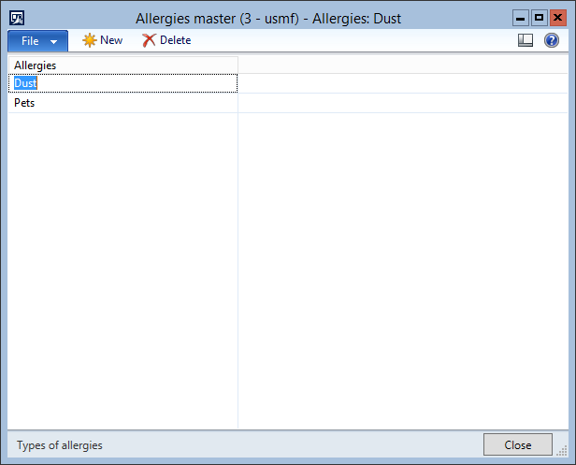

47. Click the New button.

48. Create a new record in the Allergies master form.

48. Change Allergies from '' to 'Cold'.

50. Click the New button.

51. Create a new record in the Allergies master form.

52. Click the Close toolbar button.

52. Change Allergies from '' to 'Hot'.

54. Close the Allergies master form.

### **Schema Info: FthAllergies**

Change Type: New

#### Properties

|  |  |
| --- | --- |
| **Description and Justification:** |  |
| **Property** | **Value** |
| Configuration Key | FthEventManagement |
| Label | Allergies master |
| Primary Index[7] | SurrogateKey |
| Clustered Index | SurrogateKey |
| Table Group | Miscellaneous |
| Title Field 1 | Allergies |
| Title Field 2 | RecId |
| OCC Enabled | Yes |
| Cache Lookup | None |
| Save data per company | Yes |
| AOSAuthorization | None |
| Replacement Key |  |
| Developer Documentation | FthAllergies stores the info of allergies |

#### Fields

*State all your fields and their properties; ensure identifications of H/M/LBI fields and which fields should be trimmed on the server*

|  |  |  |  |  |  |
| --- | --- | --- | --- | --- | --- |
| **Field Name** | **Data Type** | **Mandatory (Y/N)** | **Change Type** | **Configuration Key (highlight keys which can be disabled when the table configuration key is enabled)** | **Other Properties**  **(Should this field be trimmed on the server (AOSAuthorization)?)** |
| Allergies | String | No | Add |  | EDT: Description |

55. Click Area Page node: Event Management -> Common -> Event details.

1. **Form name: Event**

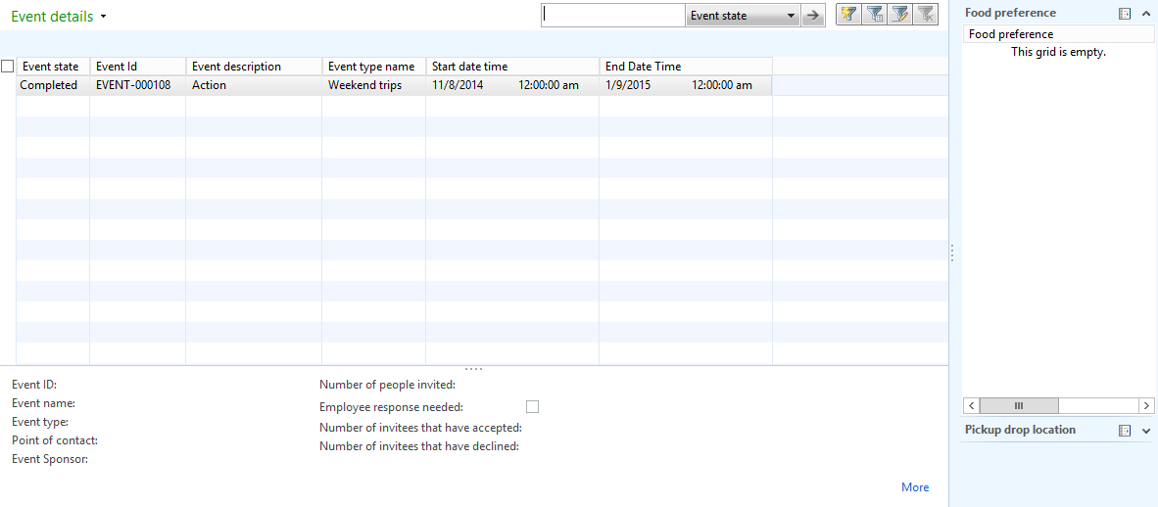

56. Click the Event -> New -> Event button.

57. Switch to the General tab on the Event form.

1. **Form name: Event**

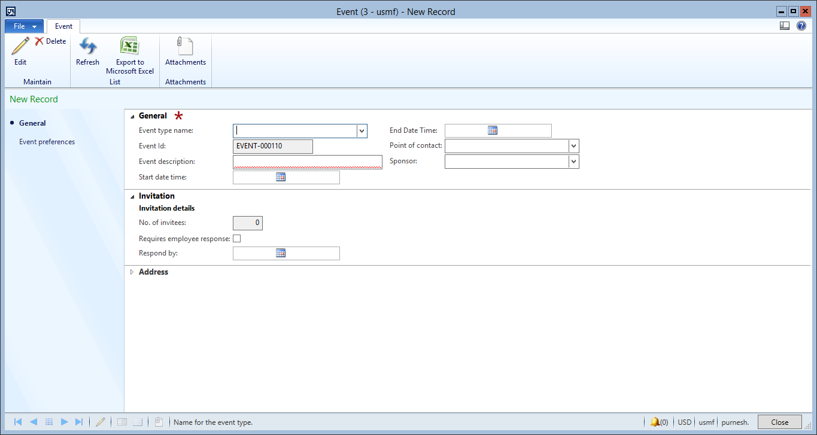

57. Change Event type name from '' to 'Overnite trips'.

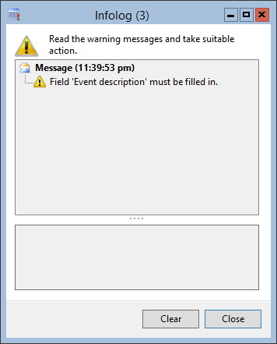

59. Click the Close button.

59. Change Event description from '' to 'Goa trip'.

60. Change Start date time from '' to '11/6/2014 12:00:00 am'.

61. Change End Date Time from '' to '11/8/2014 12:00:00 am'.

62. Change Name from '' to 'Aaron Con'.

63. Change Name from '' to 'Aaron Con'.

65. Switch to the Invitation tab on the Event form.

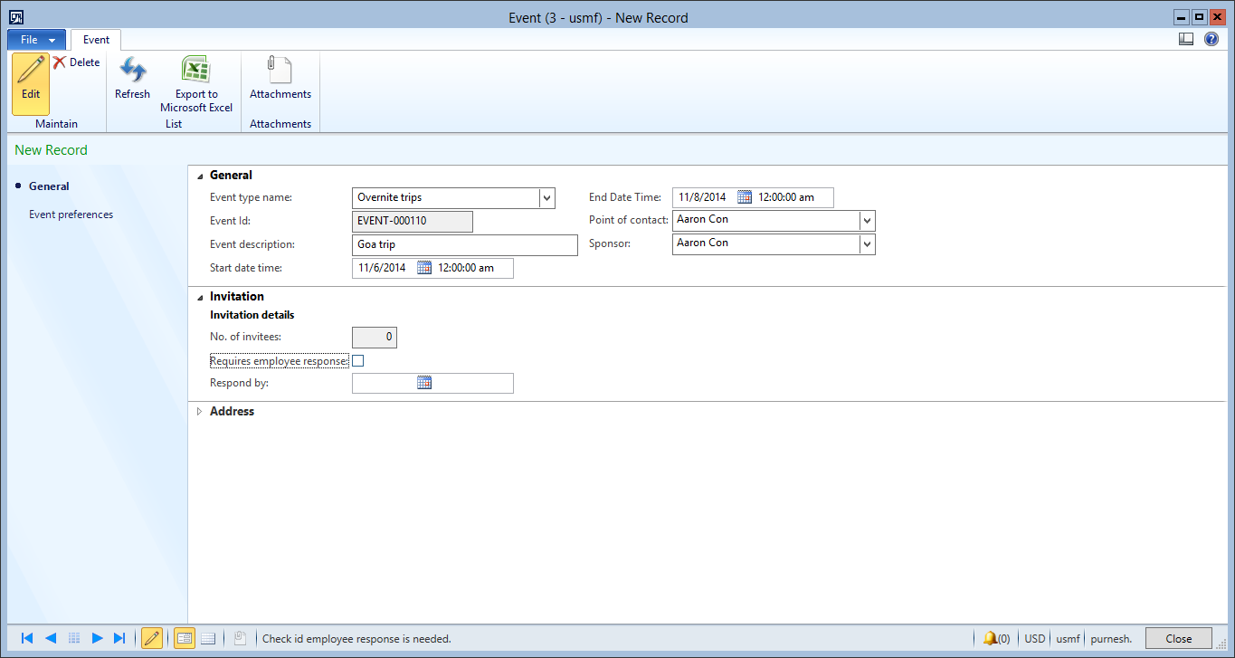

65. Change Requires employee response from 'false' to 'true'.

66. Change Respond by from '' to '11/2/2014 12:00:00 am'.

### **Schema Info: FthEventDetails**

Change Type: New

#### Properties

|  |  |
| --- | --- |
| **Description and Justification:** |  |
| **Property** | **Value** |
| Configuration Key | FthEventManagement |
| Label | Event Details |
| Primary Index[8] | SurrogateKey |
| Clustered Index | SurrogateKey |
| Table Group | Miscellaneous |
| Title Field 1 | EventId |
| Title Field 2 | Description |
| OCC Enabled | Yes |
| Cache Lookup | None |
| Save data per company | Yes |
| AOSAuthorization | None |
| Replacement Key |  |
| Developer Documentation | This table consists of basic details for every event created. |

#### Fields

*State all your fields and their properties; ensure identifications of H/M/LBI fields and which fields should be trimmed on the server*

|  |  |  |  |  |  |
| --- | --- | --- | --- | --- | --- |
| **Field Name** | **Data Type** | **Mandatory (Y/N)** | **Change Type** | **Configuration Key (highlight keys which can be disabled when the table configuration key is enabled)** | **Other Properties**  **(Should this field be trimmed on the server (AOSAuthorization)?)** |
| Approver | String | No | Add |  | EDT: Name |
| Comments | String | No | Add |  | EDT: NotesLine |
| CompanyTransport | Enum | No | Add |  | EDT: NoYesId |
| Confidential | Enum | No | Add |  | EDT: NoYesId |
| CostEstimate | Real | No | Add |  | EDT:Amount |
| Description | String | Yes | Add |  | EDT: Description |
| Direction | String | No | Add |  | EDT: FthStr200 |
| DressCode | String | No | Add |  | EDT: FthStr200 |
| EffectiveDateTime | DateTime | No | Add |  | EDT: WorkflowDueDateTime |
| EmployeeResponseNeeded | Enum | No | Add |  | EDT: NoYesId |
| EndDateTime | DateTime | No | Add |  | EDT: WorkflowStstusDateTime |
| EventId | String | Yes | Add |  | EDT: FthEventId |
| EventPoc | Int64 | No | Add |  | EDT: RefRecId |
| EventSponsor | Int64 | No | Add |  | EDT: RefRecId |
| EventState | Enum | No | Add |  | EnumType: FthEventState |
| EventType | String | No | Add |  | EDT: FthEventTypeName |
| Invitees | Integer | No | Add |  | EDT: Integer |
| Party | Int64 | No | Add |  | EDT: RefRecId |
| Recurrence | Integer | No | Add |  | EDT: Integer |
| ReferenceUrl1 | String | No | Add |  | EDT: URL |
| ReferenceUrl2 | String | No | Add |  | EDT: URL |
| ReferenceUrl3 | String | No | Add |  | EDT: URL |
| ReferenceUrl4 | String | No | Add |  | EDT: URL |
| ReferenceUrl5 | String | No | Add |  | EDT: URL |
| StartDateTime | DateTime | No | Add |  | EDT: WorkflowStatusDateTime |
| Tag1 | String | No | Add |  | EDT: Description |
| Tag2 | String | No | Add |  | EDT: Description |
| Tag3 | String | No | Add |  | EDT: Description |
| Title | String | No | Add |  | EDT: FthStr200 |
| TwitterTag | String | No | Add |  | EDT: Description |
| VenueURL | String | No | Add |  | EDT: URL |
| YammerTag | String | No | Add |  | EDT: Description |

68. Switch to the Event preferences tab on the Event form.

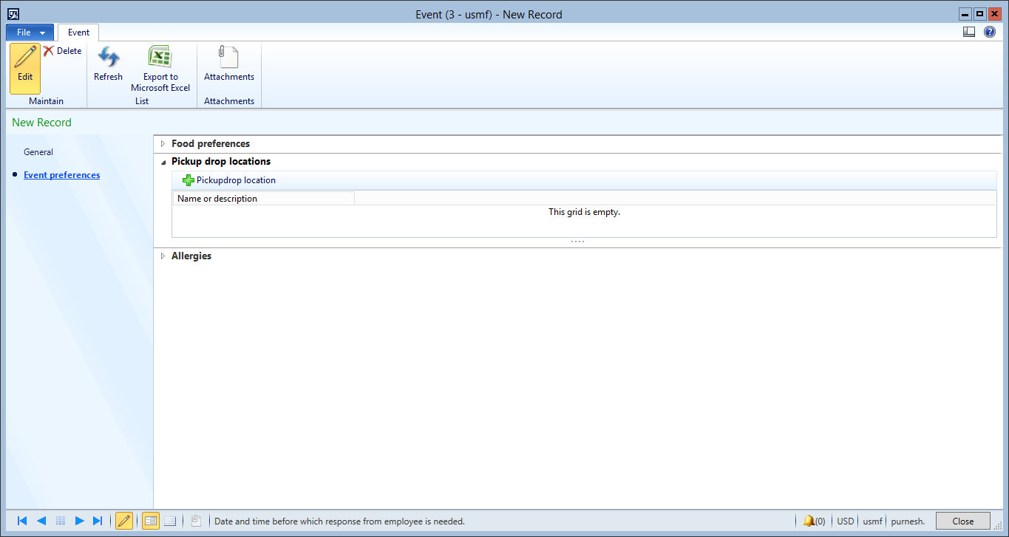

69. Switch to the Food preferences tab on the Event form.

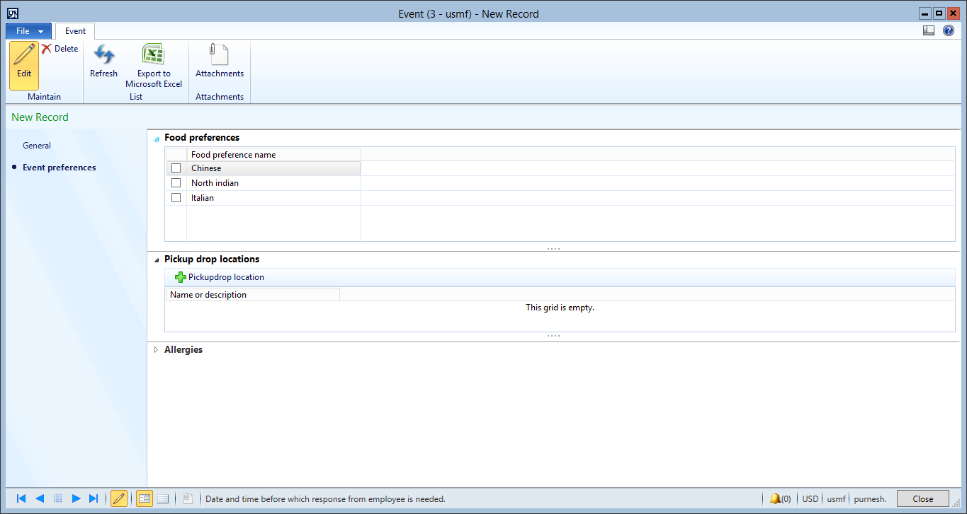

70. Make sure the selection is changed in table Food preferences to:

|  |  |
| --- | --- |
|  | **Food preference name** |
| false | North indian |

69. Change from 'false' to 'true'.

72. Make sure the selection is changed in table Food preferences to:

|  |  |
| --- | --- |
|  | **Food preference name** |
| false | Italian |

71. Change from 'false' to 'true'.

74. Switch to the Pickup drop locations tab on the Event form.

75. Click the Pickupdrop location button.

1. **Form name: Pickup drop location**

76. Switch to the Food preferences tab on the Event form.

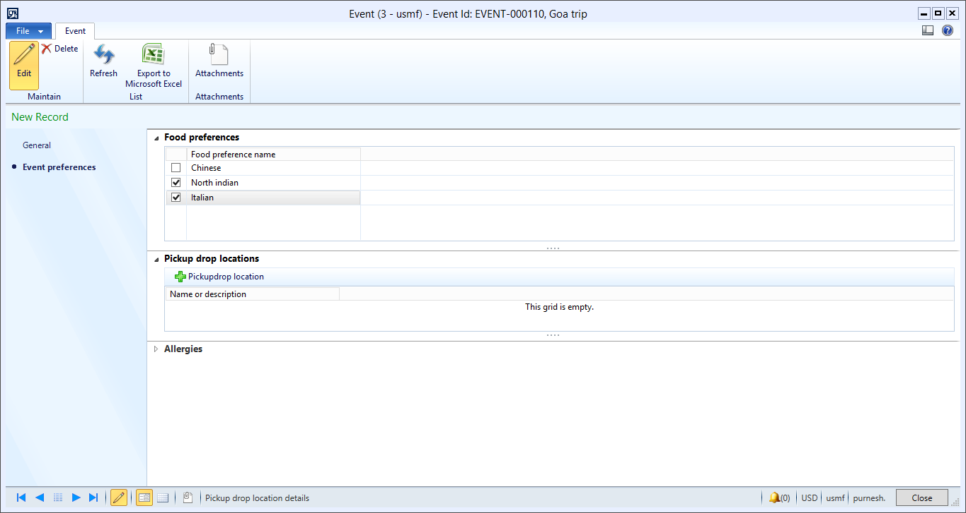

77. Make sure the selection is changed in table Pickup drop location to:

|  |  |  |  |  |
| --- | --- | --- | --- | --- |
|  | **Pickupdrop location Id** | **Name or description** | **Pickup location** | **Drop location** |
| false | LOC-000002 | Accounts | Yes | Yes |

76. Change from 'false' to 'true'.

79. Make sure the selection is changed in table Pickup drop location to:

|  |  |  |  |  |
| --- | --- | --- | --- | --- |
|  | **Pickupdrop location Id** | **Name or description** | **Pickup location** | **Drop location** |
| false | LOC-000001 | Head Office | Yes | Yes |

78. Change from 'false' to 'true'.

81. Make sure the selection is changed in table Pickup drop location to:

|  |  |  |  |  |
| --- | --- | --- | --- | --- |
|  | **Pickupdrop location Id** | **Name or description** | **Pickup location** | **Drop location** |
| false | LOC-000003 | Office | Yes | Yes |

82. Click the Close toolbar button.

82. Change from 'false' to 'true'.

84. Close the Pickup drop location form.

85. Switch to the Allergies tab on the Event form.

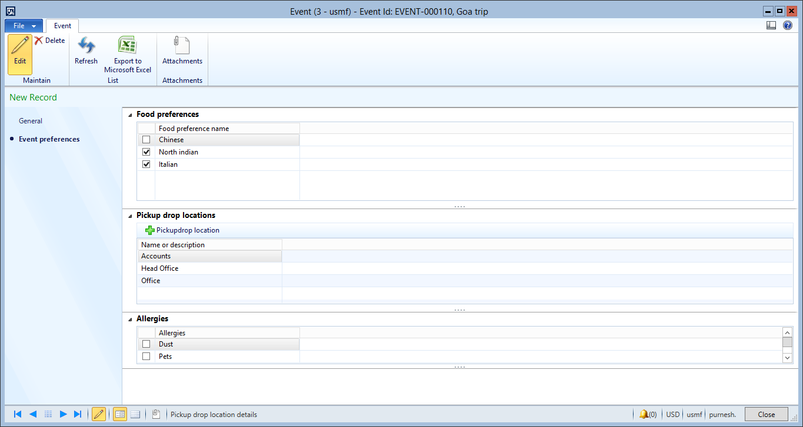

85. Change from 'false' to 'true'.

87. Make sure the selection is changed in table Allergies master to:

|  |  |
| --- | --- |
|  | **Allergies** |
| false | Cold |

86. Change from 'false' to 'true'.

89. Make sure the selection is changed in table Allergies master to:

|  |  |
| --- | --- |
|  | **Allergies** |
| false | Hot |

90. Click the Close toolbar button.

90. Change from 'false' to 'true'.

92. Close the Event form.

93. Click the Event -> Attendees Information -> Attendees Information button.

94. Click the Close button.

# Security Definitions and Role Mapping

## Privilege Definition

|  |  |  |  |  |  |
| --- | --- | --- | --- | --- | --- |
| No. | Privilege Name | Additional Information | Req. No. | Access Level | Entry Point |
| 1. |  |  |  |  |  |
| 2. |  |  |  |  |  |
| 3. |  |  |  |  |  |

*Table 7 : Privilege Definition*

## Privilege to Duty Mapping

|  |  |  |
| --- | --- | --- |
| No. | Privilege Name | Duty Name |
| 1. |  |  |
| 2. |  |  |
| 3. |  |  |

*Table 8 : Privilege to Duty Mapping*

## Duty Definition

|  |  |  |  |
| --- | --- | --- | --- |
| No. | Duty Name | Additional Information | Process Cycle |
| 1. |  |  |  |
| 2. |  |  |  |
| 3. |  |  |  |

*Table 9 : Duty Definition*

## Duty to Role Mapping

|  |  |  |
| --- | --- | --- |
| No. | Duty Name | Role Name |
| 1. |  |  |
| 2. |  |  |
| 3. |  |  |

*Table 10 : Duty to Role Mapping*

# Unit Testing

## Data Requirements

## Unit Test Plan

# Acceptance

|  |  |
| --- | --- |
| Microsoft Acceptance | |
| Microsoft Solution Architect |  |
| Date : |
| Microsoft Project Manager |  |
| Date : |
| [Company] Acceptance | |
| [Company] Business Owner |  |
| Date : |
| [Company] Project Manager |  |
| Date : |

1.
2.
3. The primary index must implement a candidate key of a relation variable. For example, the relation <RecId, FieldId> can never be a candidate key because no candidate key can have a super key (the RecId) as a proper subset.
4. The primary index must implement a candidate key of a relation variable. For example, the relation <RecId, FieldId> can never be a candidate key because no candidate key can have a super key (the RecId) as a proper subset.
5. The primary index must implement a candidate key of a relation variable. For example, the relation <RecId, FieldId> can never be a candidate key because no candidate key can have a super key (the RecId) as a proper subset.
6. The primary index must implement a candidate key of a relation variable. For example, the relation <RecId, FieldId> can never be a candidate key because no candidate key can have a super key (the RecId) as a proper subset.
7. The primary index must implement a candidate key of a relation variable. For example, the relation <RecId, FieldId> can never be a candidate key because no candidate key can have a super key (the RecId) as a proper subset.
8. The primary index must implement a candidate key of a relation variable. For example, the relation <RecId, FieldId> can never be a candidate key because no candidate key can have a super key (the RecId) as a proper subset.